RAG Mini-Project — Chat With Your Own Document
AUTHOR: AAFIA AZHAR

Document used: Flood Detection deep learning project report
(U-Net + EfficientNetB4 architecture, Dice score 0.892, IoU 0.831)

Tool used: NotebookLM a free tool by Google built specifically
for "chat with your document." You upload a file, and it can only
answer using what's actually inside that file (this is RAG in
action Retrieval-Augmented Generation).

Five Questions that I asked:

Q1: What deep learning architecture was used for the flood
detection model, and what was the reasoning behind combining U-Net
with EfficientNetB4?
The flood detection system was developed in two stages, ultimately utilizing a U-Net architecture with a pretrained EfficientNetB4 encoder
The model is designed for binary semantic segmentation, producing a mask where pixels are classified as either "flooded" or "non-flooded"
Reasoning Behind Combining U-Net and EfficientNetB4
The combination of these two architectures was chosen to leverage their specific strengths in image segmentation and feature extraction:
U-Net for Small-Dataset Precision: The U-Net framework is considered the dominant architecture for pixel-level labeling, particularly in scenarios with limited training data
Its defining feature—skip connections between the encoder and decoder—allows the model to preserve fine-grained spatial details while learning high-level semantic representations
This is critical for accurately delineating flood boundaries in complex environments
EfficientNetB4 for Robust Feature Extraction: EfficientNetB4 belongs to a family of models that use a principled compound scaling method to simultaneously balance network depth, width, and resolution
It offers a superior balance between representational power and computational cost compared to other backbones like ResNet or VGG
Overcoming Data Scarcity through Transfer Learning: The primary motivation for using EfficientNetB4 was to replace a "from-scratch" encoder (which had to learn features like edges and textures from only 832 augmented images) with a backbone pretrained on the ImageNet dataset (1.2 million images)
This allows the model to initialize with a rich understanding of general visual patterns, meaning it only needs to "fine-tune" this knowledge for the specific task of flood detection
Increased Model Capacity: The upgrade significantly increased the model's capacity for complex feature recognition. While the original scratch-built encoder had approximately 1.97 million parameters, the EfficientNetB4 encoder provides a much richer representation with approximately 19 million parameters
By combining these architectures, the developer sought to move beyond the limitations of the small dataset to achieve state-of-the-art segmentation performance
This approach was successful, with the EfficientNetB4-enhanced model achieving an IoU Score of 0.831, a significant improvement over the 0.762 achieved by the scratch-built version

Q2: What dataset was used to train and evaluate this model?
The model was trained and evaluated using the Flood Area Segmentation dataset, which is publicly available on Kaggle
Dataset Details
* Source: Compiled by Karim, Sharma, and Barman (2022).
* Composition: It consists of 290 aerial flood photographs paired with hand-annotated binary masks.
* Geographic Diversity: The images were taken during various flood events and cover diverse visual contexts, including urban, rural, and agricultural settings.
* Technical Specifications: The images are in JPEG format, while the masks are in PNG format, both resized to 256 × 256 pixels for the model.
* Class Distribution: The dataset is moderately balanced, with **40.70%** of the pixels representing flooded areas.

Dataset Split
For the development of the model, the 290 images were divided into three subsets:
* Training Set: 208 images (71.7%) used for model parameter learning.
* Validation Set: 24 images (8.3%) used for hyperparameter tuning and early stopping.
* Test Set: 58 images (20.0%) used for the final, unbiased evaluation of the model's performance.

To address the challenge of this relatively small dataset size, the training set was expanded fourfold to 832 images using a custom data augmentation pipeline.*

Q3: What Dice score and IoU (Intersection over Union) did the
model achieve, and what do these metrics indicate about performance?
The flood detection model's performance was evaluated across two stages of development, with the final, upgraded version achieving significantly higher scores than the initial baseline.
Achieved Scores
The performance metrics for both iterations of the model on the test set are as follows:

* EfficientNetB4 U-Net (Final Model): Achieved a Dice Score of 0.8920 and an IoU Score of 0.8306
* Scratch U-Net (Baseline): Achieved a Dice Score of 0.8353 and an IoU Score of 0.7621
Metric Indications and Interpretations**
In the context of this flood detection system, these metrics provide specific insights into how well the model identifies disaster zones:
IoU (Intersection over Union): This is the primary evaluation metric for the project. It measures the "pixel-level intersection" between the model's predicted flood mask and the actual ground truth. An IoU of 0.831 indicates a high degree of precision in the model's ability to classify individual pixels correctly as flooded or non-flooded.
Dice Score (F1-Score): This metric represents the regional overlap between the predicted and true flood masks. For the final model, the score of 0.892 indicates an **89.2% overlap**. While Binary Cross-Entropy loss focuses on pixel-level accuracy, the Dice Loss used during training ensures the model optimizes for these larger regional overlaps, which is considered the most important factor for "practical flood mapping".
Boundary Precision: The improvement in these scores signifies a better ability to distinguish between water and land. Visual results from the EfficientNetB4 model specifically show "sharper boundary delineation" compared to the baseline model, which often struggled where the transition between water and land was gradual.

Overall, these scores indicate that the model is highly effective and performs competitively against established benchmarks, such as those reported by Soebroto et al. (2025), who achieved a best IoU of 0.767 on the same dataset.

Q4: What challenges or limitations does the report mention about
detecting floods from the input data (e.g. image quality, class
imbalance, generalization)?
The report identifies several significant challenges and limitations regarding the detection of floods from input data, ranging from the technical constraints of the dataset to the environmental complexities of flood zones.
Data Scarcity and Overfitting
The most immediate challenge was the small size of the dataset, which contained only 290 labeled images. By deep learning standards, this is a very low number, creating a high risk of overfitting, where the model memorizes specific visual details rather than learning general patterns. For example, the initial scratch-built model had approximately **9,500 parameters per training sample**, which led to a "catastrophically unfavorable ratio" and necessitated the use of data augmentation to achieve stable learning.
Visual Complexity and Ambiguous Boundaries
Flooded regions exhibit extreme **visual diversity**, making them difficult to categorize consistently:
Diverse Contexts: Floods may appear as broad, uniform water bodies in open fields or as narrow channels winding through dense urban areas.
Gradual Transitions: A major limitation is encountered at flood boundaries where the transition between water and land is **gradual rather than sharp**. This makes binary segmentation difficult at a fixed resolution.
Spectral Confusion: In urban environments, elements like **building shadows, roads, and smooth rooftops** can produce spectral signatures similar to water, potentially confusing the model.
Data Modality and Environmental Constraints
The report highlights limitations inherent to the type of imagery used (RGB):
Weather and Time Constraints:** The model uses RGB imagery, which cannot see through **cloud cover** and is not functional at **night**. In contrast, Synthetic Aperture Radar (SAR) is the operational standard because it can penetrate clouds and capture data in all lighting conditions.
Image Source:** The dataset uses **aerial photographs** rather than true professional satellite imagery, which might hinder the model's ability to generalize to data from sources like Sentinel or NASA.
Class Imbalance and Scope of Information
Signal Asymmetry: While the dataset is "moderately balanced" (~40.7% flood pixels), it still creates an **asymmetry in the learning signal** that must be carefully managed through loss function design.
Binary vs. Qualitative Data:** A technical limitation is that the model provides **binary segmentation** (flood vs. no flood). It does not capture **flood depth or severity**, which are critical for assessing economic damage and prioritizing rescue resources.
Generalization:** Because the model was only evaluated on a test split of 58 images from the same source, its **cross-dataset generalization**—how it performs on entirely different geographic locations or sensor types—remains unproven.

Q5: What potential improvements or future work does the report
suggest for this flood detection system?
The report outlines several key areas for future work and potential improvements to transition this project from a research-focused model into a robust, operational disaster management tool.
Data and Sensing Improvements
Integration of SAR Imagery: A critical recommendation is transitioning from RGB imagery to Sentinel-1 Synthetic Aperture Radar (SAR) data**. Unlike RGB, SAR can penetrate cloud cover and operate at night, which is the operational standard for real-world flood mapping.
Larger, Global Datasets:** To improve the model's robustness across different geographic regions, the report suggests incorporating larger datasets such as **Sen1Floods11**, NASA Earth Observatory data, or Copernicus Emergency Management imagery.
Multi-temporal Change Detection:** Future iterations could use **pre-flood and post-flood image pairs**. By directly measuring visible change between these timeframes, the system could dramatically improve its detection accuracy.
Functional and Analytical Upgrades**
Flood Severity Estimation:** The report suggests moving beyond binary segmentation (flood vs. no flood) to a multi-class approach that estimates **water depth or inundation severity**. This information is vital for damage assessment and prioritizing rescue resources.
Model Generalization:** Further work is needed to evaluate the model's **cross-dataset generalization**, as current performance was only tested on a small split from a single source.
Deployment and Optimization
Real-time Practical Use:** To enable use by disaster response coordinators, the report proposes packaging the model into a Streamlit or Flask web application** for near real-time satellite imagery processing.
Edge Device Deployment:** For use in the field where connectivity might be limited, the report suggests creating a lightweight version of the model through **knowledge distillation or pruning** to allow it to run on edge devices.*

These are good test questions because the exact numbers (0.892,
0.831) and architecture choice are specific to your project — a
generic AI model with no access to your file has no way of knowing
these unless it's actually retrieving from your document.

Check for Hallucination
(NO Hallucination found)
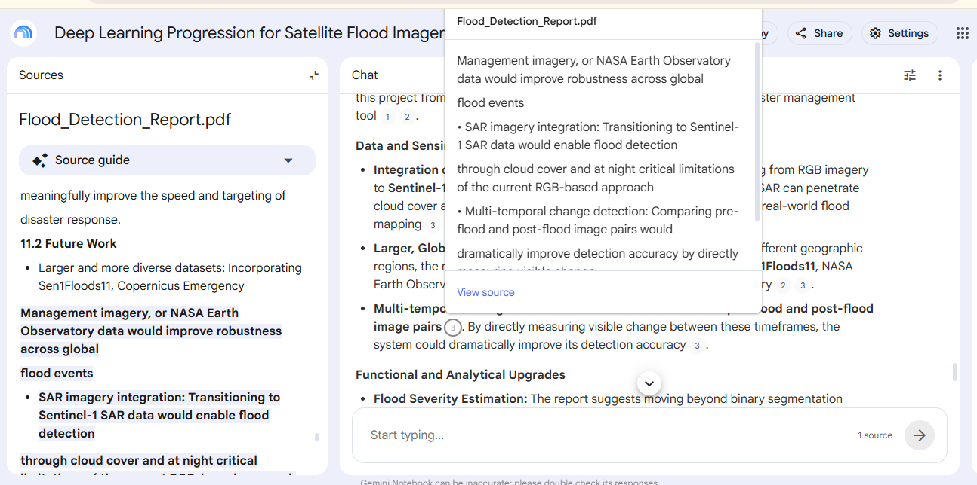

Compare to a Plain Prompt (no document)


Summary
Without the document, the model had no way to know the specific
architecture, dataset, or performance metrics of my flood detection
project it either declined to answer or gave a generic, unverifiable
guess. Once the report was grounded through NotebookLM, every answer
was tied to an actual passage in my document that I could verify
myself, so the Dice score, IoU, and architecture details it gave back
were accurate instead of invented. This is the practical value of
RAG: instead of an LLM confidently guessing based on general training
data, it retrieves and cites your actual source material — which
matters enormously for anything specific to your own work that a
general model was never trained on.

